Upgrade battery using BatteryView SOP

Wiring
According to the RJ11 pin definition in the figure below, connect wires to the DB9 female connector.
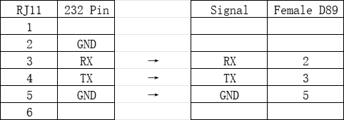

Connect battery to the computer and start the battery.
Connect step:
- Insert the RJ11 port into the CONSOLE port on the battery.
- Connect the USB interface to the computer.
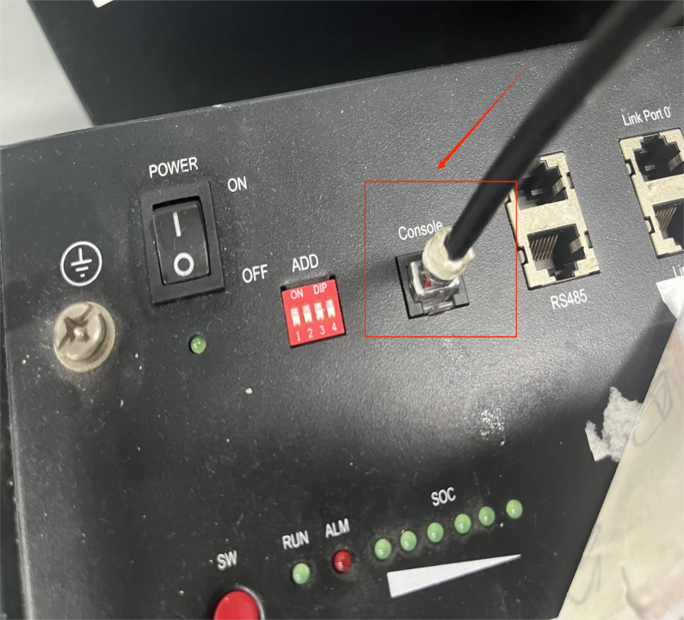
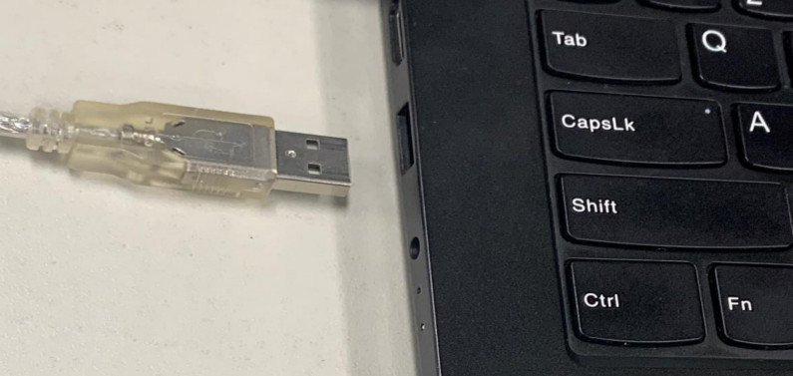
Start step:
- Turn on the battery power switch.
- Press and hold the SW switch for longer than 0.5S.

Open the BatteryView software and connect to the battery.
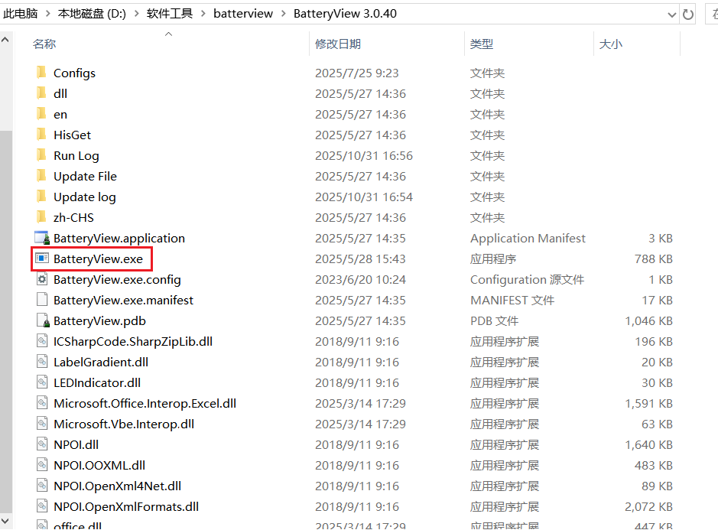
Click the "Connect" button to pop up the connection confirmation window. After confirming that the serial port and baud rate are correct, click the "OK" button to connect to the battery.
If the port name is correctly detected in ConnectDialog, skip to STEP 5. Otherwise, refer to STEP 4 to update the FT232 driver on your computer.
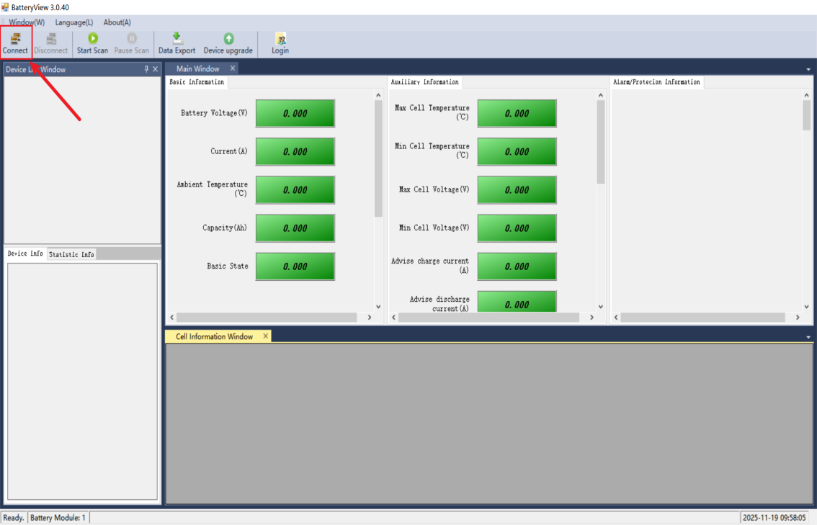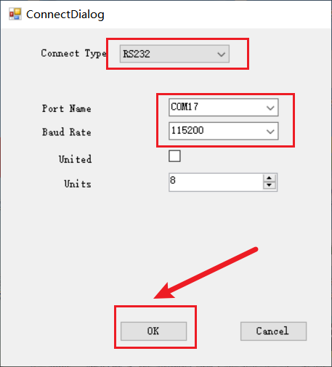
The display of device information indicates a successful connection.
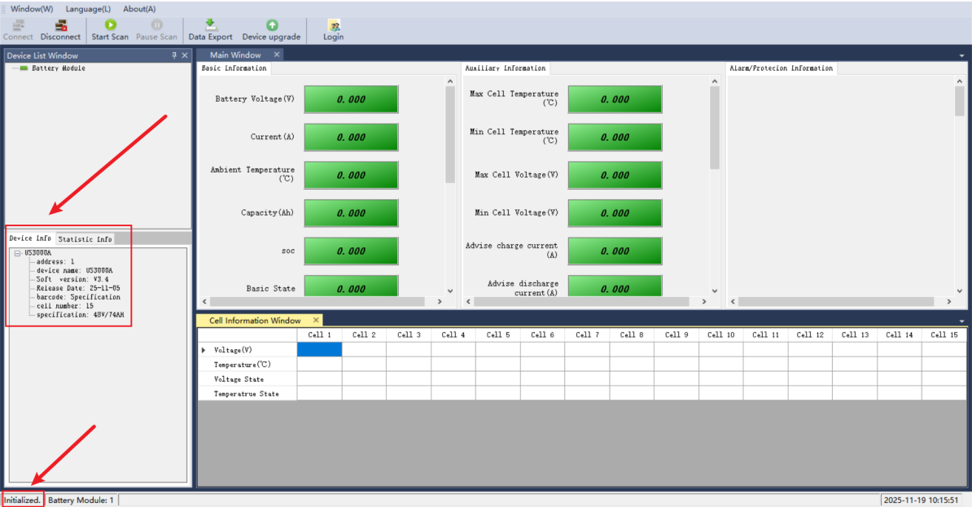

Update FT232 driver
- Open Device Manager
Method 1 (Recommended):
• Press "Win + R" to open the "Run" dialog.
• Type "devmgmt.msc" and press Enter to launch Device Manager.
Method 2:
• Right-click "This PC" (or "My Computer") and select Manage（G） → Device Manager from the left menu
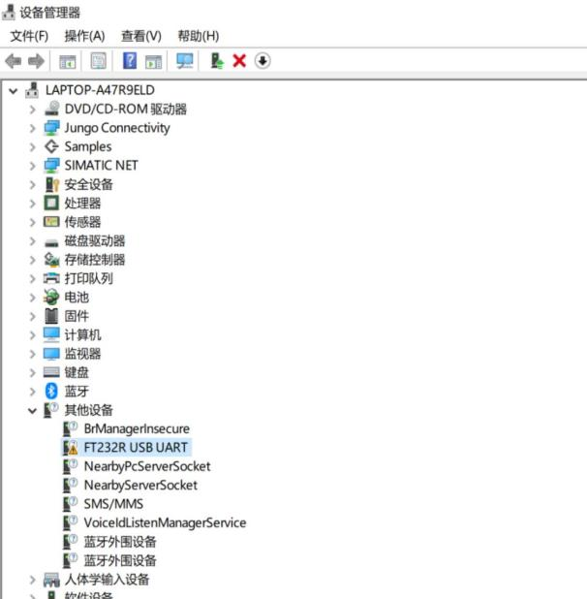
- Locate the "FT232R USB UART" Device
• Expand the Universal Serial Bus controllers or Other devices category in Device Manager.
• Identify the device labeled "FT232R USB UART" with a yellow exclamation mark.
• If the device is not visible, reconnect the USB cable and refresh.
Device Manager by right-clicking and selecting Scan for hardware changes.
- Update the Driver
• Right-click the target device and select Update driver.
• Choose Browse my computer for drivers (if you have pre-downloaded the driver files).
• Click Browse, navigate to the folder containing the extracted FTDI driver files (downloaded from FTDI,s official site，D2XX Drivers - FTDI), and select the folder.
• Check Include subfolders, click Next, and wait for the system to install the driver.
• After installation, the yellow exclamation mark should disappear, indicating normal operation.

Upgrade the battery.
After connecting the battery, click the "Device upgrade" button to upgrade the battery.
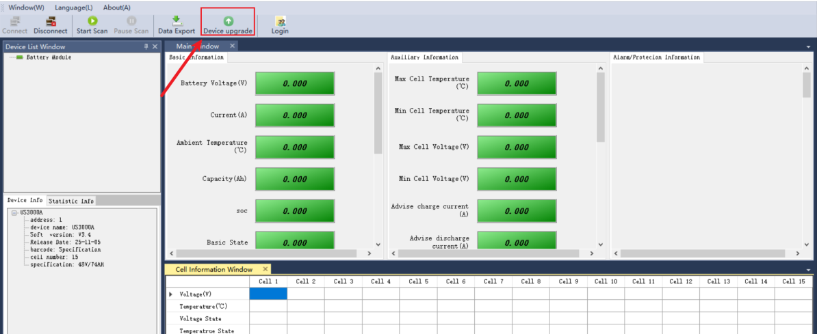
Click "Browse" to select the upgrade .bin file locally, then click "Program" to start the upgrade.
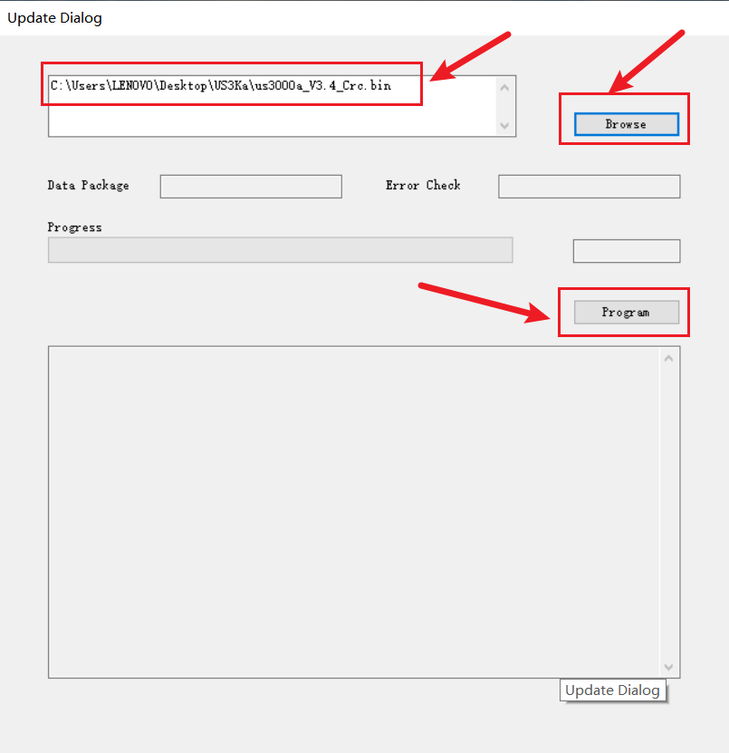
When the progress bar updates and the text box displays "The update programme starts", this indicates the upgrade has commenced.
If a Coulomb Input Dialog appear during the upgrade process, simply click "Cancel " to proceed with the upgrade.
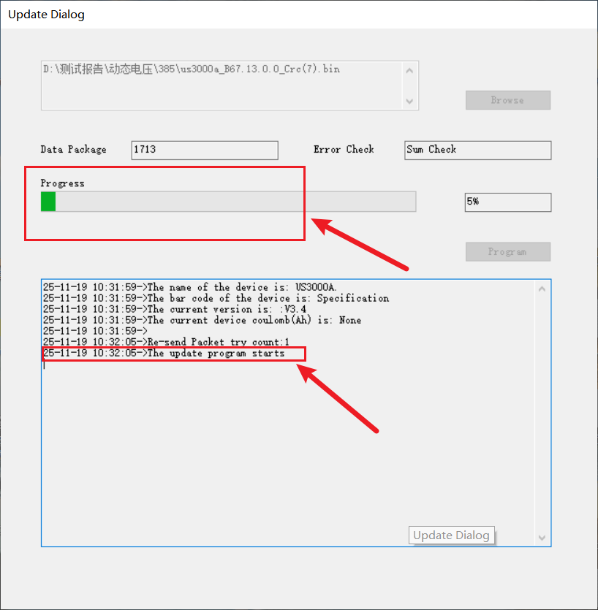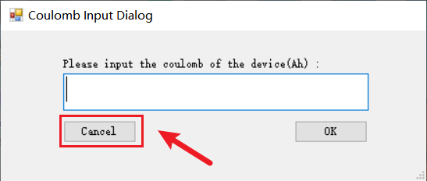
When the progress bar displays 100% and the text box shows "Update is finished ", this confirms the upgrade is complete.
Click "Complete " to end the upgrade.
